*Lab 2: DDL Commands*

1. Employee (eno char(3), ename varchar(20), eadd varchar(30), ephone char(8), esal int, grade char(1), edoj date, dno char(3), emgrno char(3))

* PRIMARY KEY – eno
* FOREIGN KEY – dno refers to Department relation
* FOREIGN KEY – emgrno refers to eno of Employee relation
* salary can hold values between 1000 and 60000
* grade can be A – if salary less than 20000, B – if salary is between 20000 and 40000, C – if salary is greater than 40000
* doj should be more than 01-jan-1990
* ephone can have unique values only

*SOURCE CODE*

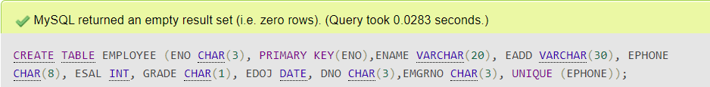

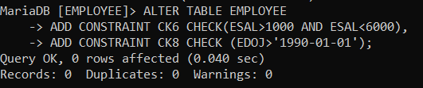



*OUTPUT*

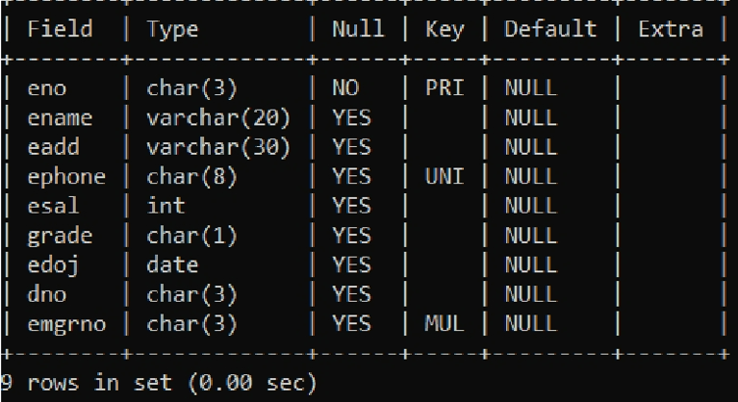

1. Proj_alloc (eno char(3), pno char(3), hrs int).;;;

* PRIMARY KEY – eno, pno
* FOREIGN KEY – eno refers to Employee relation
* FOREIGN KEY – pno refers to Project relation
* hrs can have values more than 2

*OUTPUT*

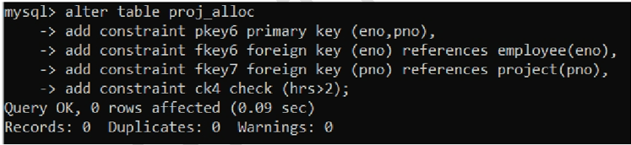

1. Dependent (eno char(3), dpname varchar(20), dpdob datetime, dprelation varchar(20))

* PRIMARY KEY – eno, dpname
* FOREIGN KEY – eno refers to Employee relation
* Dprelation can have only one of the values {son,daughter,father,mother}

*OUTPUT*

